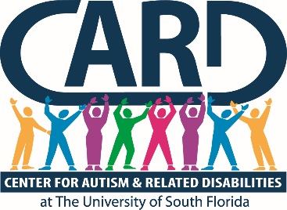

University of South Florida
Center for Autism and Related Disabilities
Final Report and Year End Summary

2016-2017

Submitted By

Karen A. Berkman, Ph.D.
Executive Director

August 7, 2017
University of South Florida (USF)
Center for Autism and Related Disabilities (CARD)
Final Report and Year End Summary
2014-2015

USF CARD Current Registry

 | Registry Data as of  June 30, 2017 | Comparative Data from June 30,2016
Registry Total | 6390 | 5802
Constituents on Registry by County
Charlotte | 101 | 101
Collier | 164 | 162
Desoto | 21 | 22
Glades | 0 | 2
Hardee | 29 | 19
Hendry | 27 | 25
Highlands | 129 | 116
Hillsborough | 2822 | 2461
Lee | 357 | 351
Manatee | 183 | 176
Pasco | 728 | 674
Pinellas | 1007 | 941
Polk | 588 | 525
Sarasota | 234 | 227
Constituents on Registry by Age
0-2 | 26 | 39
3-4 | 244 | 227
5-15 | 3164 | 2915
16-21 | 1476 | 1311
22+ | 1480 | 1310
Annual New Referrals/Intakes | 708 | 764
Annual Registry Losses | 50 | 40
Annual Web Hits | 4,076,135  (218,794 visitors) | 3,337,942 (124,714 visitors)

*Registry total includes 6324 constituents with autism spectrum disorders (ASDs) and 66 with related disabilities (RDs). ASDs include autistic disorder, Asperger’s disorder, pervasive developmental disorders—not otherwise specified, Rett’s disorder and childhood disintegrative disorder, and RDs include dual sensory impairments or sensory impairments with other disabling conditions.

In accordance with section 1004.55, Florida Statutes (F.S.), and Rule 6A-7.0335, Florida Administrative Code (F.A.C.), USF CARD provided non-residential resource and training services for persons of all ages and levels of intellectual functioning with a documented diagnosis of autism, a pervasive developmental disorder not otherwise specified, an autistic-like disability, a dual sensory impairment or a sensory impairment with other disabling conditions. Services were coordinated with local and state agencies and school districts in an effort to not duplicate services. USF CARD worked closely with its partner agencies across the state of Florida to ensure high quality and equitable local, regional and statewide service provision in accordance with Rule 6A-7.0335, F.A.C., and consistent with the longstanding mission and values of the Florida CARD, a Florida Department of Education (FDOE) program since 1993. USF CARD primarily provided services within its 14-county catchment area, but also collaborated with other CARD centers and state agencies/projects on regional (e.g., regional trainings, Partnership for Effective Programs for Students with Autism [PEPSA] program) and statewide initiatives (e.g., annual CARD conference, development of online training content, support of statewide performance plan indicators, support for the reading initiative). Service delivery was consistent with the other six statewide CARD centers and was coordinated in the collective development of our projects’ annual service plans and via phone conferences with CARD directors and FDOE’s CARD liaison.

Outlined in this report is a summary of activities engaged in by the USF CARD during the period of July 1, 2016, through June 30, 2017. An abbreviated quantitative summary of center constituent registry and service activities is also presented, which reflects our activities across all relevant variables specified in our grant award agreement with FDOE. Detailed programmatic activity and constituent contact data can be found in the project tracking system (PTS) database.

In accordance with Rule 6A-7.0335, F.A.C., USF CARD implemented a plan that included the following:

- A staffing plan with, at minimum, individuals with expertise in autism or autistic-like behaviors and individuals with expertise in sensory impairments.

USF CARD prides itself on having a highly qualified multidisciplinary staff with impressive longevity in terms of years of service to the project. Our project staff members are professionals with expertise in the following discipline areas: psychology, behavior analysis, special education, social work, public health and music therapy. Our executive director has been with the project since 2003, and our director has been with the project since 2004. This continuity of leadership has contributed a high level of expertise and administrative stability to our project, which has certainly served to enhance our project performance and outcomes. Our project leader also participates in service grant writing, fundraising, publications and presentations, and is recognized locally and nationally as an expert in the field.

- A direct service plan that must address individual and family assistance in the home, community and school. The project shall not supplant responsibilities of other state and local agencies.

USF CARD provided individual and direct family assistance (IDFA) across contexts (home, school, and community) in fiscal year (FY) 16-17. IDFA is defined by the CARD centers as any contact with any individual and/or family in reference to a specific CARD constituent. Families are advised of the range of services provided by USF CARD and how to access those services when needed. Detailed information on how to access USF CARD services is also available on our website (http://card-usf.fmhi.usf.edu/). All new families who require services complete an intake with a CARD consultant, where the constituent and family needs are assessed and a service plan developed. The CARD consultant with whom the family meets is assigned to the family for ongoing individual and direct family assistance and all related future clinical contacts. IDFA contact data are collected regularly, entered into CARD’s Filemaker reporting database, summarized quarterly and entered into the PTS for quarterly and annual reporting.

Summary of Annual IDFA Data

Total IDFA contacts delivered annually | 7619
Total number of individuals served annually | 14603

- A technical assistance (TA) and consultation services plan for providing specific intervention and assistance, utilizing all available community resources, to clients of the project, the clients’ family, school districts, and other service agencies and individuals as appropriate.

USF CARD provided Technical Assistance (TA) services throughout our community in FY 2016-17. TA is defined by the CARD centers as assistance requested by an agency or program that is not related to a specific CARD constituent. Agencies requesting such services are directed to a TA request form on our website (http://card-usf.fmhi.usf.edu/services/request/technical-request.html). Once a completed form is received by our central office, a CARD consultant with expertise relevant to the TA request is assigned to contact the agency, assess need and determine a plan of action. TA contact data are collected regularly, entered into CARD’s Filemaker reporting database, summarized quarterly and entered into the PTS for quarterly and annual reporting.

Summary of Annual TA Data

Total TA contacts delivered annually | 4342
Total number of individuals served annually | 8858

- A professional training program plan that includes developing, providing and evaluating pre-service and in-service training in state-of-the-art practices for personnel who work with the populations served by the project and their families.

USF CARD provided extensive local and regional trainings for professionals in FY 2016-17 in an attempt to ensure that all professionals working with CARD constituents are trained in state-of-the-art “best practices” and are highly qualified. All USF CARD trainings are open to all interested parties in the community, including family members, at no cost. Agencies requesting training are directed to a training request form on our website (http://card-usf.fmhi.usf.edu/services/request/training-request.html). Once a completed form is received by our central office, a CARD consultant with expertise relevant to the training request is assigned to contact the agency, assess need and determine a plan of action. We continue to expand the array of online training content each year. Training data, including participant demographic information, and participant evaluations are collected regularly and entered directly into the PTS for quarterly and annual reporting.

Summary of Annual Training Data

Total number of onsite local trainings/workshops | 187
Total number of participants | 5036
Total number of times online trainings viewed | 1988
Total number of visitors for online training page | 5109
Total number of annual regional trainings/workshops and/or summer institutes | 3
Total number of participants | 850

- A public education plan to increase awareness of the public about autism, autistic-like disabilities of communication and behavior, pervasive developmental disorders, dual sensory impairments, and sensory impairments with other disabling conditions.

CARD hosted or participated in numerous public education and awareness events throughout our catchment area in FY 2016-17, including regional community resource and health fairs, autism awareness events with professional sporting franchises (e.g., Tampa Bay BUCS); and many others. Specific events and related data can be found in the PTS.

Summary of Annual Public Education/Awareness Data

Total number of annual general public education presentations | 65
Total number of participants | 11446

- Description of how the project will interface with the medical community to ensure the appropriate use of medical consultation in the provision of services.

USF CARD maintained collaborations with the local medical community, specifically consulting with hospital employees and adaptive care committee to problem solve issues related to patients affected by autism; reviewed training opportunities for hospital staff; consulted with hospitals on using best practices for children diagnosed with autism; disseminated an emergency information packet called Medipal for families to use on a child’s seatbelt or backpack with medical information in an emergency; expanded the medical provider information in the CARD Filemaker database. A resource and referral database of medical providers by discipline has also been maintained. Lastly, we have an ongoing partnership with Special Day Foundation and UF College of Dentistry where CARD provides annual trainings and ongoing technical assistance to new dental residents. We have also created a variety of social experience stories and visual materials for dental offices to ease patient stress and anxiety.

- Description of its working relationship with and support of the constituency board, as defined in s. 1004.55, F.S.

USF CARD continued its close collaborative relationship with its constituency board. The board has maintained its membership of people who represent several USF CARD counties. The constituency board reviewed annual program budget and goals, and hosted quarterly meetings with CARD staff to review programmatic and budgetary priorities. The constituency board operated in accordance with approved by-laws, and proposed constituency board members’ names were submitted to the presidents of USF and the Autism Society of Florida, as specified in statute. Constituency board members participate actively in fundraising events to help support USF CARD operations. Finally, board members participate in relevant trainings related to their own and their family’s needs and interests throughout the year, including the annual CARD conference.

- Dissemination of Appropriate Nutritional Information.

CARD-USF disseminated appropriate nutritional information to constituents in various formats. Information about finding health food choices, latest research to address picky eating and strategies and an article on food allergies and sensitivities
was posted to our website along with visual supports and a fact sheet on reading snack food labels. Lastly, we posted an informative newsletter on what dieticians should know to serve individuals with autism. Trainings on nutrition are archived on the USF CARD website and are available for ongoing viewing by families.

Summary of Supplemental Activities in Support of Program Objectives

The USF CARD executive director has been engaged in working collaboratively with other entities within and outside of USF in supporting the ever-expanding scope of our project and our growing community needs. The USF CARD executive director continues to collaborate with Home Instruction Program for Parents of Preschool Youngsters (HIPPY) to apply their evidence-based model for school readiness to children diagnosed with autism with positive results thus far. This project is funded through the Children’s Board of Hillsborough County. USF CARD has completed the development of a visual enhancement to the HIPPY curriculum, which has been tested in FY 2016-17 with new referrals of three-year-old children. These projects have allowed us to enhance our program by engaging in important research and related clinical service work. Last, we were an invited participant on site visits with FDOE to follow up on monitoring and providing TA to school districts that were flagged for seclusion and restraint issues.

As required, USF CARD board and staff have also been quite active on the fundraising front, raising over $45,800 to support our program to offer the community educational opportunities and activities. Included among these efforts are two major events; our annual Fiesta By the Bay fundraising event, and the Rotary Cycling event (funds from the rotary were donated to The Learning Academy Success Fund for this 2016-2017 FY). The CARD Champion giving society has over 200 members who donated and/or hosted third-party events to benefit USF CARD. USF CARD also takes the leadership role with the CARD Autism Champion student organization at USF.

USF CARD continues to strengthen its program through the cultivation of strategic community partnerships. This past year, we continued building on the close relationships with our 14 school districts, continued our collaboration with the medical and diagnostician community through trainings and resource dissemination, and enhanced our community outreach efforts through numerous public awareness efforts, in collaboration with local schools/agencies.

We were pleased to plan and host or co-sponsor the following annual, regional or local community-based conferences: CARD Conference (state), CARD/PEPSA Summer Institute, a Hispanic conference and two additional PEPSA regional teacher trainings. We continue to update the content on our online training page of the USF CARD website. The training module on preventing seclusion and restraint for educators continued to be widely disseminated across our state with data tracking by directors of each CARD center.

Our team continues to offer regularly distributed substantive and informative newsletters. The CARD Connector is a brief monthly newsletter that clinicians from around our communities may contribute to as well as our constituency board chair along with announcements. The CARD Community Connection newsletter is a full edition that comes out two times a year. They are both on our website archives.

USF CARD offered several Sibshops in different counties this year for children ages 7-12. These events were an opportunity for siblings of children with ASD to make connections, gain peer support and education within a recreational context. Sibshops are lively and fun. While the effects of Sibshops might be therapeutic, Sibshops are not therapy.

USF CARD has successfully completed another year of its “autism friendly business initiative” having worked with over 50 large and small companies in and around the Tampa Bay region. During this fiscal year, USF CARD partnered with the City of Tampa to become “autism friendly.” We started the process by assembling content and developing materials for the City of Tampa Police department in order to train all law enforcement personnel. In addition, training and materials have been delivered to 12 parks and recreation facilities within the city. Lastly, we created an online social experience story for the downtown Riverwalk area of the city for families to download. USF CARD staff will be appointed to the Mayor’s Advisory Committee in the 2017-2018 fiscal year to continue expanding and monitoring this project.

We collaborated with the Florida Aquarium to host the Day of Discovery as well as the Florida Orchestra to offer “Autism Friendly” and sensory friendly experiences for CARD constituents and the general public. Our website showcases this effort and provides families with information on the businesses who have completed our training and created products to help visitors feel welcome (http://card-usf.fmhi.usf.edu/community/business.html).

USF CARD was designated as one of three centers in Florida to implement a program to prevent wandering called Project Leo. During this one year pilot for Hillsborough County, we distributed 210 radio frequency tracking devices purchased through Safetynet to individuals diagnosed with autism across the age span. Of the individuals who received this device and wandered from home, all were returned safely within 30 minutes by the Hillsborough County Sheriff’s Safetynet team. In addition, CARD-USF created and distributed 102 safety kits to assist families in keeping family members safe at home (http://card-usf.fmhi.usf.edu/resources/materials/safety.html?tab=4 ).

2016-2017 CARD Annual Caregiver Satisfaction Survey

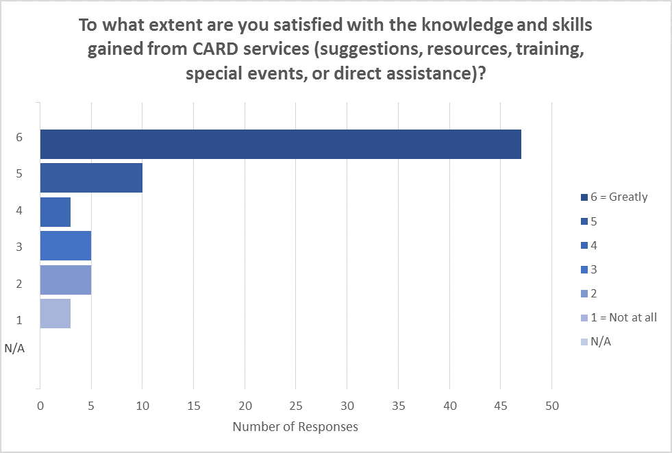
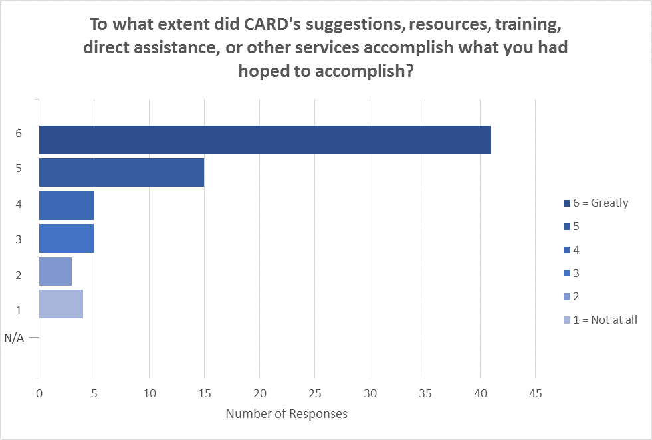

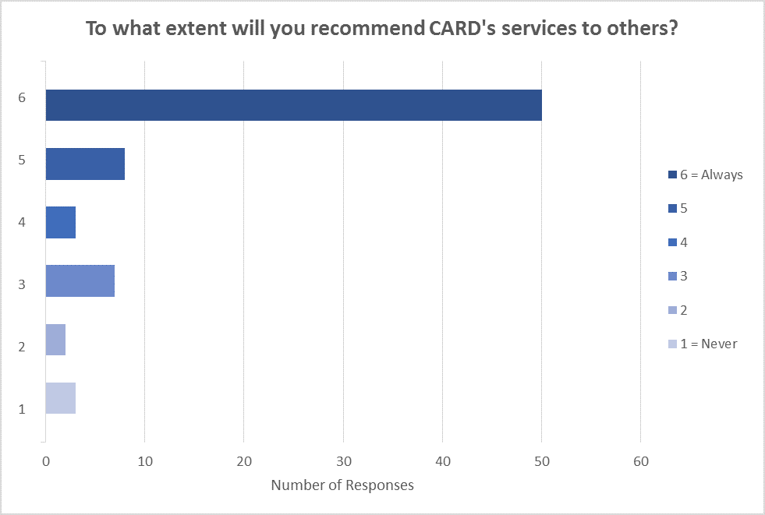
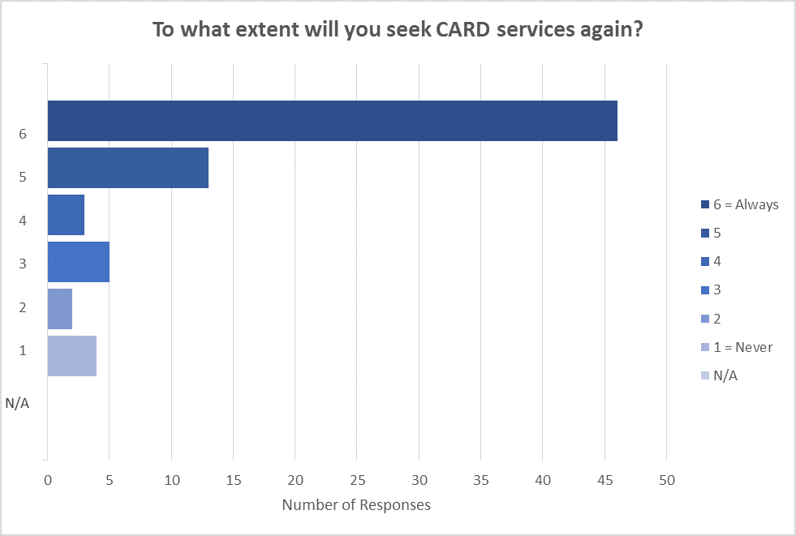
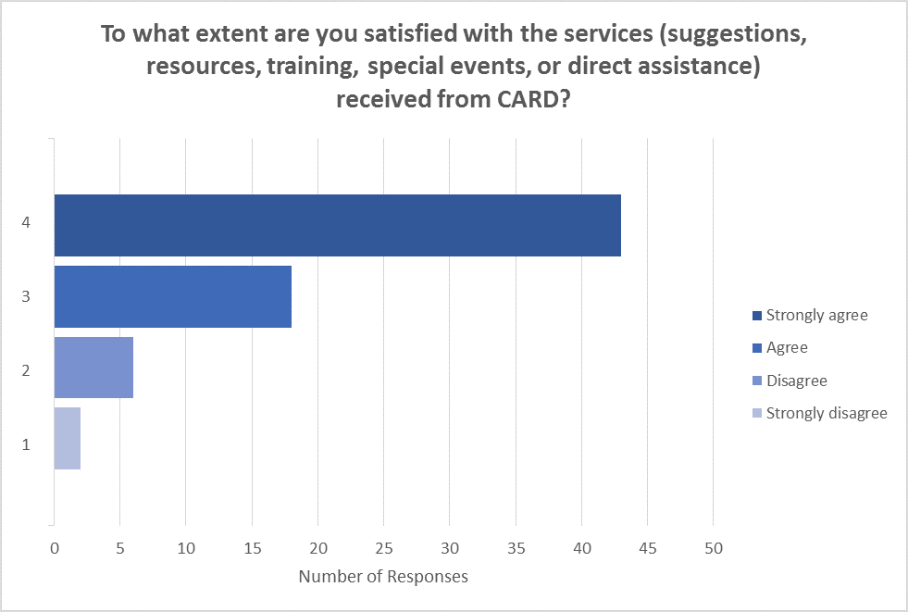
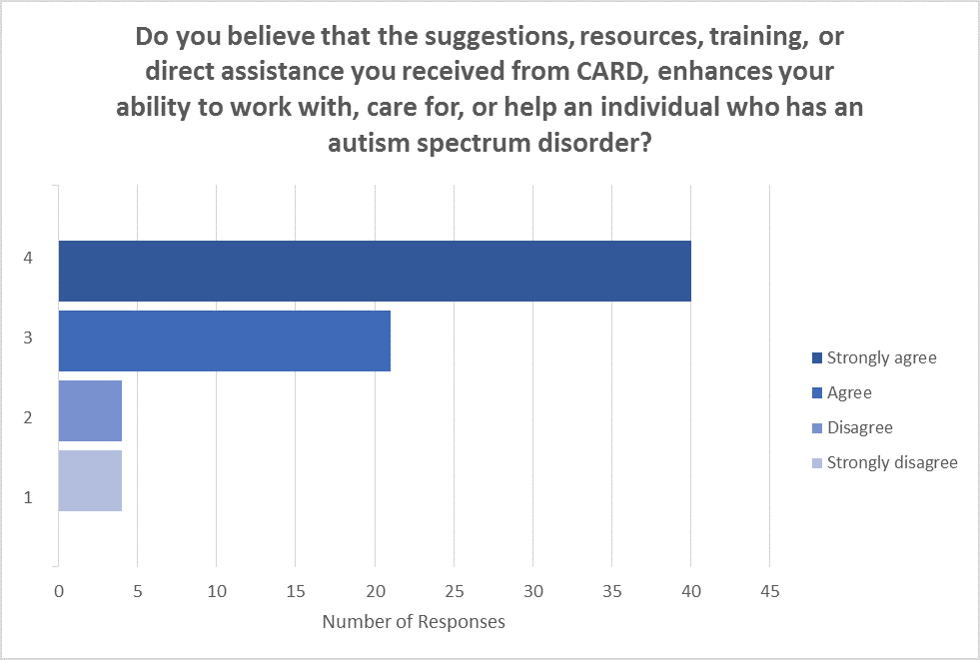
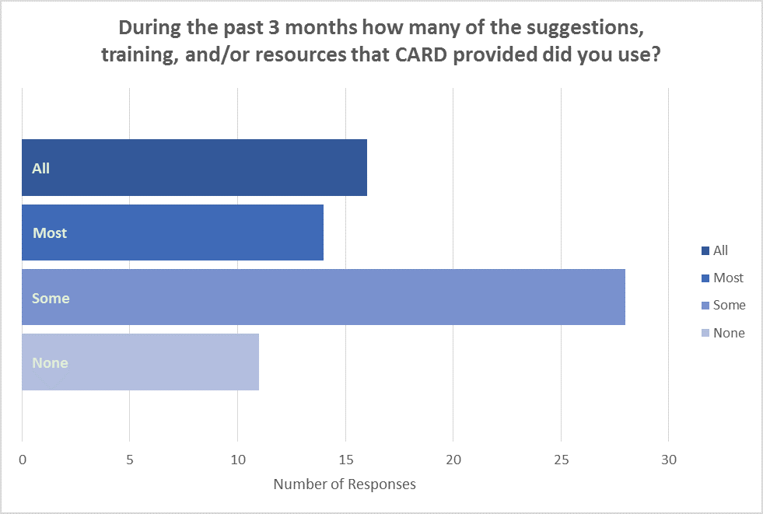
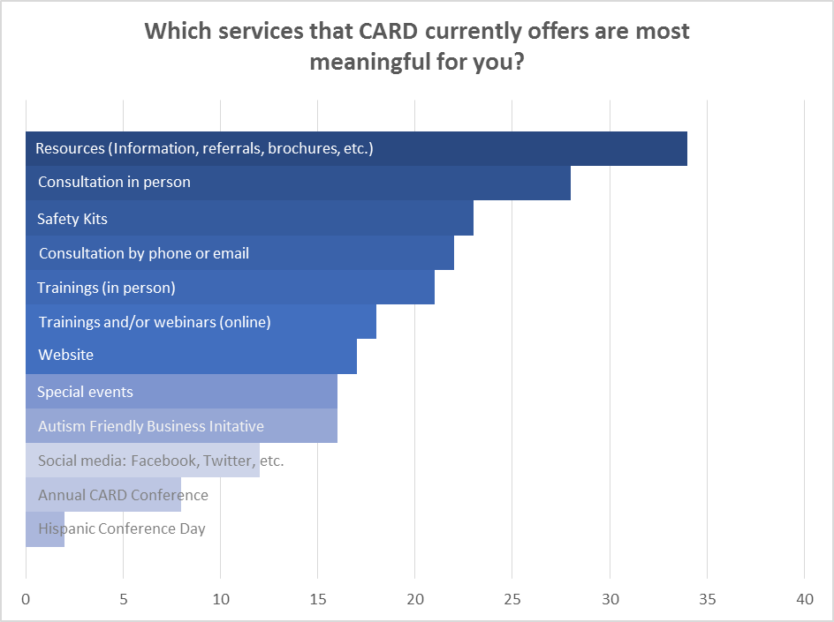

2016-2017 CARD Satisfaction Survey for Technical Assistance

